Tutorial 8: Human Resource / Process Modeling

Tutorial Overview
This week’s tutorial is about Human Resource. Human resources are the most important asset of any organization. They are the ones who create the products and services that the company offers, and they are the ones who drive the company's success. The HR department is responsible for a wide range of tasks, including recruiting and hiring new employees, onboarding and training new employees. developing and administering employee benefits and others.

Tutorial Learning Outcome
At the end of this tutorial, students should have an idea of the role of human resource in recruitment and also have a practical hands-on on modelling HR processes.

The Activity
This activity is an individual activity.

Activity 1: Your Dream Job
Describe a position (i.e system analyst, business development manager, database administrator, ERP consultant etc) in a company that you would like to have. What type of information must be collected to determine if a candidate is appropriate for this job? List the skills that you think would be required for this position.

For this activity, the GA will provide a brief overview of what Human Resource is. Try to relate the overview with the Your Dream Job activity. Your Dream Job activity relates to the recruitment process.

Activity 2: Process Modelling
The following scenario depicts the recruitment process for ABC Company.
Sarah, the manager of the Marketing Department at ABC Company, identifies a need for a Digital Marketing Specialist to support the team's growing workload. She submits a hiring request to the HR department, outlining the position requirements, such as proficiency in SEO, social media marketing, and Google Analytics. The HR team reviews Sarah's hiring request and conducts a job analysis to gain a comprehensive understanding of the Digital Marketing Specialist role. They identify the key responsibilities, required skills, and qualifications needed for the position. Based on the job analysis, HR creates a job posting that highlights the job description and desired qualifications. The posting is shared on the company's website, popular job boards, and relevant social media platforms to attract potential candidates. After a week of posting the job, the HR team receives numerous resumes from interested candidates. They begin the resume screening process and shortlist candidates who possess relevant experience, qualifications, and skills in digital marketing.The shortlisted candidates are invited for the first round of interviews. Sarah and the HR representative conduct face-to-face interviews to assess the candidates' technical knowledge, creativity, and cultural fit within the team. The interviews focus on understanding the candidates' experience in running successful digital marketing campaigns and their familiarity with the latest industry trends. Following the initial interviews, the top candidates are asked to complete a skills assessment. They are given a hypothetical digital marketing scenario and asked to develop a comprehensive strategy, including campaign objectives, target audience, and marketing channels. Impressed by the skills assessment results, Sarah and the HR team proceed with conducting reference checks for the final candidates. They reach out to their previous employers or professional contacts to verify their work ethic, performance, and overall suitability for the position. Additionally, background checks are conducted to ensure the candidates have a clean record. Sarah, together with HR and other relevant stakeholders, reviews the interview feedback, skills assessment results, and reference checks. After careful consideration, they select the most qualified candidate, Emily, who has a strong track record in digital marketing, excellent communication skills, and a proven ability to drive results. Sarah and the HR team extend a job offer to Emily, outlining the salary, benefits, and start date.
- Identify problems in the recruitment process that might lead a candidate to develop a negative opinion of the company. How might an effective information system reduce the potential for these problems?
Student might give various response. For example
- Resume are stored by the HR dept manual. With IS, the resume can be stored digitally in a repository and download the resume when required.
- Inaccurate information of the job announcement.
- Departments get inaccurate information about workforce planning.
- And any other problems.
Information systems can be used in storing and managing resumes, conducting analysis on work force planning etc. HR will receive hiring request from department online and HR systems can conduct job analysis automatically.

- Draw a flowchart and swimlane diagram of the recruitment process for ABC Company
Sample flowchart and swimlane diagram. The flowchart is the process model without the swimlane
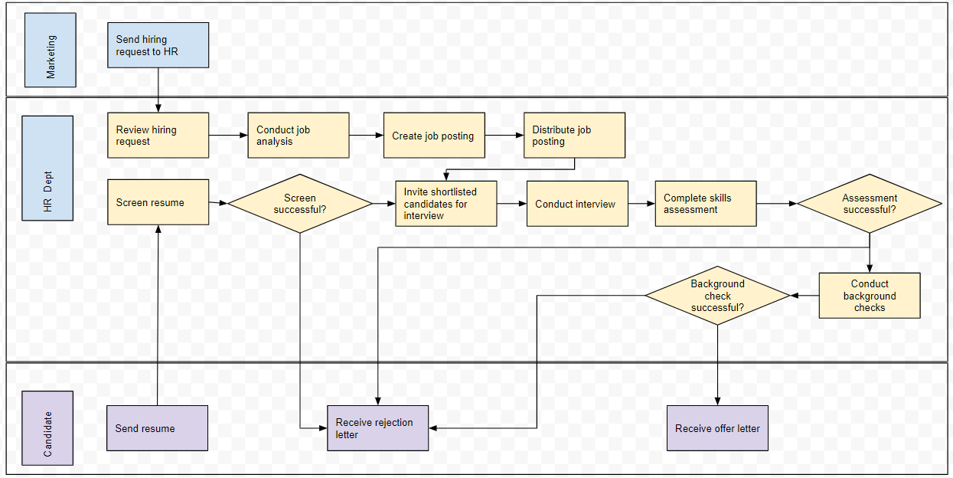

The Submission
The GA will update you on submission of this tutorial.

The Assessment
This tutorial might be assessed by the tutor.
-END OF TUTORIAL-

